Journal
of Comparative
Physiology · B
1 bv Sprin cr- \'crlaJl)'

Intrapulmonary Variation of Gas Partial Pressures and Ventilation Inequalities in Chelonian Reptiles

Warren W. Burggren 1 *, Mogens L. Glass 2 , and Kjell Johansen 2

1 School of Biolo ical Sciences. University of East i\nglia, Norl\ich. Norfolk "R4 7 Ll_ l:ng\and
' Department of Zoophysiology, University or Aarhus. DK-XOOO Aarhus C. Denmark

Accepted April 5. 197X

Summary. I) Variations of respiratory gas partial pres­ sures. as well as ventilation inequalities in different regions of the lungs of unanaesthetized, unrestrained PsezlilcmL\- scripta. Testudo gracca and Tcstudo her­ nwnni have been examined. Both direct cannulation of the lungs and indirect methods involving instanta­ neous monitoring of expired gases have been used.
2) Respiratory gas pressures vary between lateral
chambers of the lungs by less than 3-4 mmHg. The data indicate that ventilation and perfusion in un­ disturbed animals are normally matched to a similar extent throughout a large portion of the lung. No pulmonary ventilation inequalities normally occur.
3) In contrast. distressed Pscudcmrs show marked
ventilation inequalities. presumably induced by pos­ tural changes including head and limb withdrawal into the carapace.

Introduction

The morphology and mechanics of lung ventilation have been examined in both fresh water and terrestrial Chelonia (Marcus. 1937; Gans and Hughes. 1967: Gaunt and Gans. 1970). in Ophidia (Rosenberg. 1973) and in the Crocodilia (Gans and Clark. 1976). Other authors have reported on the nature of ventilatory control in reptiles which normally breath either inter­ mittently or continuously (see review by Wood and Lenfant. 1976: Glass et a!.. 197il). The periodic. dy­ namic nature of pulmonary perfusion and the mecha­ nisms influencing it have also been investigated (see review by White. 1976: Shelton and Burggren. 1976: Burggren. 1977; Johansen et a!.. 1977). Recently. the quantitative relationship between overall lung ventila­ tion and perfusion as influenced by chemoreceptor­ mediated control of both functions has been examined

Present address: Department of Zoology. Univ. of British
Columbia. Vancouver. British Columbia. Canada V6T I W5
DEPART CNT OF ?OOLOSY
UNIVEF\sr,··; c:; 1 • ,,_·_ .:JTS
AMHERST, [\';,'.!: .\C.::.; -·--;·:::; 0; :J03
(Burggren eta!.. 197il). In spite of this accumulation of data. little is currently known about regional varia­ tions in pulmonary function in reptiles: their lungs remain essentially respiratory ·black boxes·.
In mammalian lungs considerable stratification of both perfusion and ventilation may occur. and \enti­ lation-perfusion ratios. >-· Pco, and R vary consider­ ably on a regional basis (West. 1974). Whether regional differences in gas tensions predicted for reptilian lungs (Wood and LenfanL 1976). as well as regional \cntila­ tion-pcrfusion inequalities. exist in chelonians re­ mains to be established. The lungs of the carpet py­ thcm show considerable stratification of perfusion (Read and Donnelly. 1972). but their elongation and striking division into saccular and alveolar com­ ponents may preclude direct comparison of ophidian lungs with those of other reptiles. Chelonian lungs are generally much less alveolized than those of mam­ mals. and the bronchial system is also considerably less developed. However. the presence or absence of ventilation inequalities cannot easily be predicted simply on a morphological basis. The situation may be further complicated in reptiles by normally occur­ ring periods of apnoea, which could tend to mask pulmonary ventilation inequalities and regional gas partial pressure variations by allowing time for diiTu­ sion of gases between lung compartments.
The object of the present investigation was to de­ termine the extent of variation in respiratory gas par­ tial pressures in different regions of the lungs of un­ anaesthctized and unrestrained Chelonia. Standard. non-intrusive tests of pulmonary function were also employed to assess the extent of ventilation inequa­ lities.

Materials and Methods

Experiments \\ere perrormed on II 'pccimen' of the turtle
P1eudcllll"\ scriplll. and the tortoise' Te.l!udo gruem and Tnrudo lierlll(flllli. weighing between 700 and II 00 - ;\\\ experimenh \\ere
performed at 20 22 oc

0340- 7616f7X/O 126/0203;so 1.40

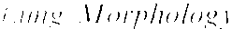

I ungs \\LTC careful!) cxpnscd and rcmmcd from l'rcshlj killed
/'1('/li/emn and Tntudo. In f(·studo the lungs adhere vcr) close!) to the vertebral column and pelvic girdle. "' a portion of the plastron and skeleton was disseckd out with each tortoise lung.
!"he main bronchus of individual lungs was occlusively cannulated.
and the lung intlatcd to an intrapulmonary pressure of approxi­ matcl) 5 cmll 2 0. The inllated lung was then 'air-fixed· for 24 h at a temperature of 50-60 °C (Tenney and Tenney. 1970). The internal structure of the air-fixed lung was then examined hy dissec­ tion.

l.znzg Cannulation and Gas Ti'11.1'ion Measuren1ent
A medial

anterior

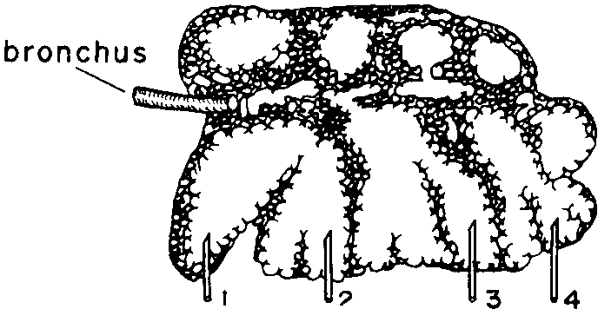2
gas sampling cannulae

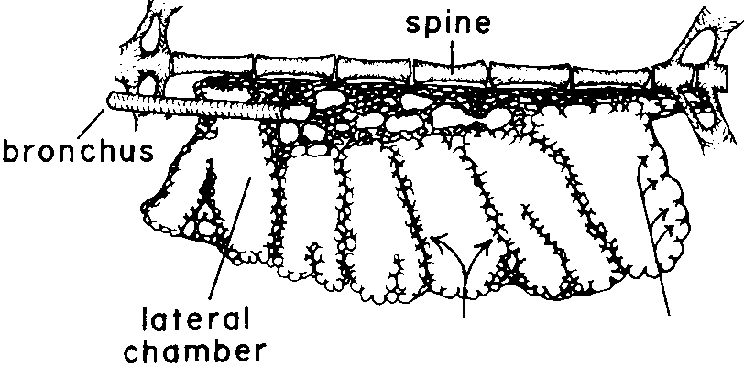B

posterior

Anaesthesia for cannulae implantation was induced with cold tor­
por h) placing the animab in a I oc cold room for 12 15 h hcforc
surgcr). Details of the lung cannulation technique have hcen given clse1v·here (Burggren. 1975). The animals were allowed to warm to room temperature and recover for 24 h after surgery, and were unrestrained and unanaesthctized during the course of all experi­ ment\. Chronically implanted lung cannulae remained patent for several days. and the subsequent dissection of animals sacrificed after experimentation to determine the exact cannula location tT­ vcaled little or no pulmonary contusion or edema.
Pulmonary gas samples were drawn directly from unanacs­ theti/ed animals with cannulae which were chronically implanted in 4 different lateral chambers of the same lung. Invariably. the most anterior and posterior of the lateral chambers were cannu­ lated. The other two cannulae were implanted in two of the more central lateral chambers at points equally spaced from each other and from the most anterior and posterior cannulae hee Fig. I for cannulae locations). 0.2 ml samples of lung gases were drawn simultaneously from each of these 4 lateral cham hers immediately l'ollowing the final inspiration of a breathing series (P.\1'/lllemrs) or a single inspiration ( Testudo). Total volume of each gas -;ample series was O.X mL and compared to the 60 XO ml single lung volume of the anin1als rerresented an insignificant change in puln1onary volume. Cas samples were analyzed for 1'0 , and Pco, in a Radiome­ ter BMS J hlood gas analy/er which was frequently calibrated. Partial pressures of' expired gas were ana1)'7ed on a hrcath-to-hrcath has is \1 ith a Searle Vledspect II mass spectrometer. A hollow pla-;tic cylinder 4 mm in internal diameter and 40 mrn long was glued over the nostril-; of the animaL The shaft of a hypodermic needle was inserted through the wall of thi' plastic cylinder to within I mm of the nostrils. The sampling catheter or the mass spectrometer was attached to the needle and continuously sampled gas from immediately in front of the nostrils at a rate of 30 mljmin.

Results and Discussion

Representative drawings of sagittal sections through the right lung of a Pscudcmrs scripta, T. graeca and T. hernwnni are presented in Figure I. After entering the lung. the first generation bronchus immediately di\idcs into a short anterior and a longer posterior branch in all three species. In T. hermanni the second generation bronchi are well defined, hea\ily ringed with cartilage, and run in the medial region of the lung directly to the anterior and posterior regions of the parenchyma (Fig. I C), but in T. graeca and P.1eudcmrs scripta the intrapulmonary bronchi are

1° septa 2° septa

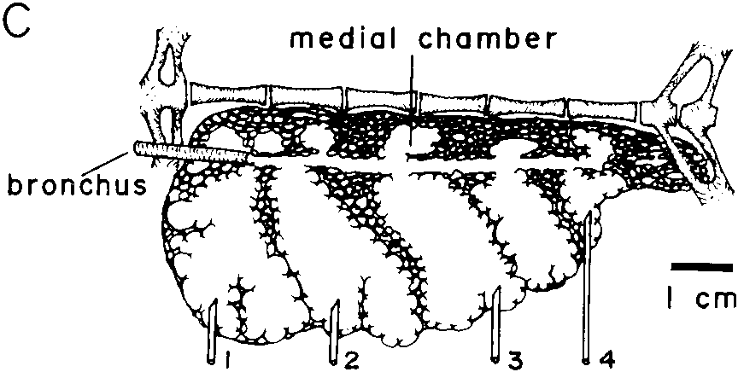
Fig. I A-C. Diagrammatic drawings in a ventral aspect of represen­ tative sagittal sections midway through air-fixed right lung prepara­ tions from A Pseudemrs scripta, B Ti'.\tudo graeca and C Testudo hcrnwnni

much less distinct. A third generation of very short bronchioles given off along the length or the bronchus immediately open without further branching both into small medial chambers formed by the presence of extensive tertiary septa and into 5-8 larger lateral chambers of variable size formed by primary septate divisions. Hence. with only 3 4 generations of airways, anatomical dead space is very smalL amount­ ing to less than 0.5'/':, to 1.5"1., of total lung capacity in P.1eudemrs and Tcstudo. respectively (Crawford et a!.. 1976). The lateral chambers, whose walls dc\clop only secondary septa, share primary septal walls and their longitudinal axis is approximately perpendicular to the longitudinal axis of the lung (Fig. I). Rarely there are non-bronchial connections in the primary septal walls between lateral chambers. Thus. Wolf
( 1933) has reported a few such connections bet ween
lateral chambers, but Gans and Hughes (1967) were unable to find any evidence for them in Testudo gracca. There is a marked latero-medial gradation

I ahk I. I )l,tr!hution nr respiratory gas partial pre"urcs in the lateral chamber' of the lungs ol 1'\('1/dl'/1/l'l and Fn!l!do. \lean ;!luc' ' I
''·""Lml de' iation arc presented. Location of sample sites arc indicated in I· igurc I

SJlL'l'll''-. | umber or measu rem en ts |  | Anterior chamber | Mid-anterior chamber | Mid-posterior chamber | Posterior chamber | Lc\cl of ignificancc of anterior/posterior
 |  |  | (site I) | (site 2) | (site 3) | (site 4) | difTcrcncc
 |  |  |  |  |  |  | (site l/sitc4)
I f'\!l!do gran·a | 17 | Pol | 144.5 ± 3.3 | 143.5±3.6 | 1430±3.6 | 142.5±32 | 0.001
 |  | Pcol | 12.1 ± 1.2 | 12.2±1.1 | 12.5:+:1.3 | 13.0 I U | 0 ()2
·rc !udo graeca | 10 | Po, | 141.9±2.5 | 141.0±2.4 | 140.4±2.1 | 140 () -2.2 | 001
 |  | Pen,
rc.,flulo grucca | 12 | Po, | 141.0±3.6 | 140.5±3.4 | 137.2+3 5 |  | O.OUI
 |  | Pco.
I n1111io her/Jiallni | X | Po, | 13 .7±1.5 | 137.3±1.5 | 135.6 ± 1.7 | 133.6 • 2.0 | () 01
 |  | Pco} | 9.9±0.9 | 10.7+ 10 | 11.:1±1.1 | IJtJ ± 1.0 | 0 002
re,!udo l!crmanni | 13 | Po, | 137.1±27 | 136.4 ± 2.5 | 135.X + 2.6 | 1.'5.5=2.(1 | 0.001
 |  | Pco, | 13.3+07 | 137±07 | 13.9 ± 0 X | 14.0 +0.9 | 0.02
fJ\CtU!CinyscrtjJta | 5 | Po, | 97.0±1.\.7 |  | 95.2 + 17.4 | 9.\.0 ±I X . .\ | n .s.
 |  | Pco,
p,cudc!Jiys scrtjJta | 7 | Po, | 123.9± 9.5 | 12U±9.1 | 12J.O ± 9.0 | II X 6 ± 9.5 | 0.05
 |  | Pco. | IX.2 ± 5.9 | 19.4±77 | 20.7 ± 6.X | 215 t 5.9 | 0.02
P\cudcJny.\ scripta | 13 | Po, | 122.X ± 6.X | 1212±7.1 | 120.3+10.9 | 119.0 :+: 9. .\ | 0.05
 |  | Pco.

ol' secondary and tertiary septa with the medial re­ gions of the lung extensively subdivided into nu­ merous chambers ranging from 0.5 5.0 mm in diam. (Fig. I). In the Chelydridae and the Testudinidac the complexity of the lung often decreases posteriorly (Marcus. 1937). but this tendency is not very evident in Pscudcmys scripta or Tcstudo gracca.
The distribution of respiratory gas partial pressures
along the longitudinal axis of the lung of the three species is indicated in Table I. Mean values of gas pressures occurring simultaneously in different lateral chambers of a single lung in each animal were determined. Relative to the regional variations in lung gases. there was considerable variation in the absolute levels of P0, and Pea, both between animals and between consecutive breaths in individuals. especially in Pscudcmrs. The latter was mainly the result of varying interbrcath intervals. Significance levels of differences in gas pressures between the most anterior and posterior lateral chamber in each measurement were assessed with a Student's paired or dependent
1-test. In every animal examined P0 , was significantly higher and Pea, significantly lower at the anterior
end of the lung than at the posterior end. with a gradation of values between these two regions. How- ever. the overall variation in gas partial pressures throughout the lateral chambers of the lung at any given time usually was less than 3-4 mmHg, and more often barely within resolution of the gas analysis
equipment. In two animals gas sampled simulta­ neously from identical positions in the left and the right lung were found to contain identical gas compo­ sitions. Although data in Table I were derived from gas samples taken immediately after inspiration, nu­ merous other experiments revealed essentially the same gas tension distribution after I min of apnoea.
Wolf(l933) has proposed an 'avian· flow pattern
in turtle lungs with inspired air first passing directly to the posterior chamber before entering the anterior chambers where most respiratory gas exchange oc­ curs. If correct. gas tensions in posterior chambers would closely reflect inspired gas tensions. while P0 , and Pc0 , in the anterior regions would be much closer to pulmonary capillary blood values. Gans and Hughes (1967) refuted Wolfs (1933) hypothesis of sequential ventilation by examining measurements of intrapulmonary pressure gradients in Tcstudo gracm. The present study brings more direct evidence against this hypothesis by the demonstration of a ncar uni­ form distribution of respiratory gases along the longi­ tudinal axis of the lung.
Wood and Lenfant ( 1976) predicted that the het­ erogeneous structure of the chelonian lung would re­ sult in regional differences in pulmonary gas composi­ tion. Investigations of pulmonary gas exchange rely­ ing upon representative lung gas samples would hence have questionable value. Clearly. in P.1cudcmrs and Tcstudo. however. regional gas partial pressure differ-

R Pco 2
1.0 j A
0.8
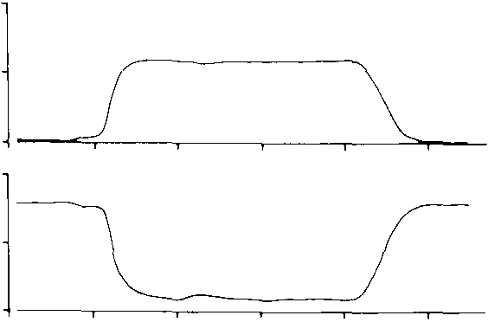40
ratios empty at diff'crcnt times during expiration. The
\alue of the pulmonary gas exchange ratio R. \\hich depends on the relationship between ventilation and perfusion. will change during the course of a single expiration if regional ventilation-perfusion mismatch­

(mmHg) 20
0
160
Po2
ing occurs. P0 , and Pco. measured during continuous
sampling at the nostrils normally revealed no alter­ ation of the gas exchange ratio during the expiratory phase (Fig. 2A). This finding indicates that ventilation

(mmHg)
140

120

Time (sec)

B
and perfusion are matched to yield a uniform gas
exchange throughout the lungs. corroborating our hy­ pothesis first based on direct measurements of gas partial pressures from different lateral chambers. If. however. a turtle was disturbed. resulting in head and limb withdrawal into the carapace. the gas ex­
change ratio showed lluctuations indicati\c of \Cntila­

R 0.9j ..../\ = ----
0.7 v
40
Pco 2 20
c:_
(mmHg)
0
160
tion-perfusion inequalities (Fig. 28). These likely resulted from an altered pattern of intrapulmonary ventilation and/or perfusion.
Few studies have addressed regional differences in the relationship between pulmonary ventilation and perfusion in other reptiles under any conditions. An altogether different situation might be expected in

Po2
(mmHg)

140 I
I
/
Ophidia. most of which have non-respiratory air sacs as elongate caudal extensions of the alveolarized lung

120 -------.-
- /
sections. Donnelly and Woolcock ( 1972) reported that

Time (sec)
Fig. 2A and B. Expired respiratory gas tensions and calculated pulmonary exchange ratio during a single expiration (A) in an undisturbed P11'1idcmr.' .ICI'ifJ/11 and (B) in a highly stressed turtle
11 ith its head and limbs withdrawn deeply into its shell

ences are very smalL at least between the large lateral chambers which constitute by far the greatest volume of the lungs. Samples drawn from the lateral chambers should hence be considered representative of gases throughout a large portion of the lungs. A considerably greater degree of ·alveolation· medially than laterally could result in medio-lateral variations in pulmonary gas composition. The extent of such heterogeneity in gas pressures remains unknown.
Since direct non-bronchial connections between
lateral chambers rarely occur. the uniformity of respi­ ratory gas partial pressures along the longitudinal axis of the lung could result from an even ventilation of the various regions of the lungs. The observed uniformity of pulmonary gas pressures could alterna­ tively arise if variable blood perfusion matched an uneven ventilation thus ·correcting' or masking the latter. Uneven ventilation-perfusion matching in the lungs can be revealed by the continuous monitoring of respiratory gas pressures during single expirations (West et al., 1957) if. as for mammals. regions of the lungs with quite different ventilation-perfusion
gas ventilation and alveolar P<h (and hence perfusion)
were stratified along the alveolar region of the lungs of resting carpet pythons. During exercise. however. PA0, increased disproportionately so that identical values were recorded throughout the alveolar lung. indicating that ventilation and perfusion became more evenly matched under these conditions. Read and Donnelly ( 1972) showed that postural changes from a horizontal to a vertical position in the carpet python resulted in a much more even perfusion of the alveolar regions of the lungs. but data on ventilation stratifica­ tion were not presented.
It must be emphasized that a close matching of
rates of gas ventilation and blood perfusion in various regions of the lungs does not a priori indicate that all lateral chambers are equally \entilated (here de­ fined as each having the same fraction of their volume renewed with inspired air during a single respiratory cycle). A pulmonary compartment which has a low "turnover rate' of gas with each breath but which is also perfused at a low rate can contain gas with identical partial pressures to that of a highly perfused. highly ventilated compartment. The presence of re­ gional ventilation inequalities in the lungs of the Che­ lonia was assessed using two methods. The first tech­ nique involved indirect determination of gross re­ gional ventilation inequalities by recording the wash­ out of residual nitrogen from the lungs following a single inspiration of l 00''/r, 02 . At the start of expira-

,Inc \ cntilation in Chcloman Reptile,

ll•IL the 1\. or the expired gas will rise sharply as the pulmonary dead space containing IOO'Y., 02 is progressively washed out with alveolar gas containing
1"' 2 . As expiration continues, the rate of increase in P,. will fall as ·pure· alveolar gas begins to be expired past the nostrils. If in all sections of the lungs the a me fraction of gas is renewed with each respiratory c;clc. the P'l, of expired gas will level off and stabilize,
201

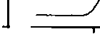A
400

200
0>
0
E

forming an ·alveolar plateau'. Smaller inequalities in
regional ventilation will not be disclosed by this tech­ nique. but if there are gross ventilation inequalities in the lung. perhaps caused by variations in airway resistance or sequential inflation and deflation of compartments. such that these various compartments
fill and empty at different rates, then the PN, of the
.;} 400 B
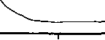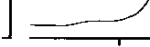(L

200

0

Time (sec)

expired gas will continue to change throughout expi­
ration and an alveolar plateau will not be formed.
Four unrestrained, unanesthetized Pscudcmrs scripta were subjected to single breath pulmonary function tests. Figure 3A shows a representative re­ cord of PN. measured in a turtle during expiration l'ollowing inspiration of pure 02 towards the end of a long breathing series. An almost completely level
·alveolar plateau' in the expired P,, profile was con­
sistently obtained in undisturbed turtles with the sin­
Fig. 3A and B. P,, profile' mea,ured during a single expiration ol·
lung ga' after inspiration of 100", oxygen in (A) an undisturbed PseudC'mL\ scripta and (B) a highly stressed Pseudemr.1 scripta with head and limbs withdrawn deeply into its shell

100 .....................·._.-...:·.·.......[100 ·..... : ....·......·:·......·...._....··. r; fR
. . . [ . . . . . . [0
. 0

z
N

"0
gle breath technique. However. an expired PN, profile 10
Q)
a.
characteristic of pulmonary ventilation inequalities X
Q)
could be experimentally induced in turtles which had been provoked to deeply withdraw their head and
limbs into their carapace (Fig. 3 B). When these turtles A
. ·.
10

B

..
·.·.·

were left undisturbed and assumed a more relaxed
posture. alveolar plateaus in the PN, profile returned
I
0 20 40
1+-----r-----.------
0 20 40

during expiration.
A second. more informative method used to assess ventilation inequalities is the multiple breath method, based on the rate of N 2 washout from the lungs dur­ ing many successive breaths of pure 02 (see West,
1974). In evenly ventilated lungs nitrogen in different
pulmonary regions is reduced by the same fraction with each inspiration of 02 , and there is an exponen­ tial decrease in expired N 2 with each breath. When multiple pulmonary compartments exist. N 2 in com­ partments with a high rate of gas transfer falls rapidly with each breath, while N 2 in poorly ventilated, slowly emptying compartments falls less rapidly. If
\entilation inequalities exist. then a plot of log end­ tidal N 2 against the number of 02 breaths will not be linear (monoexponential), but will instead consist or an initial rapid fall in log N 2 as the well ventilated compartment exchanges 02 for N 2 , followed by a long period of a more gradual N 2 washout of the poorly ventilated compartment(s). Thus, unlike the single breath method, ventilation inequalities will be revealed even in the unlikely event that all regions of the lung fill and empty at exactly the same time,

Number of breaths
Fi!(.4A-B. Nitrogen washout from the lungs of a voluntarily breathing Pseudemys scripta during: many successive breaths of JO()"Io 02 . In (A) arc presented the results of a typical experiment on a comparatively undisturbed turtle. In (B) the turtle was hig:hl) stressed and had its head and limbs deeply withdrawn into its shell. Respiratory frequency (I"R) during the course of each experiment is also indicated

provided that tidal volume and breathing frequency don't undergo a sustained change to new levels during the course of each experiment. Figure 4A shows a typical plot of log end-tidal N 2 concentration against number of breaths in 100% 02 during a long breath­ ing senes m an unrestrained. unanaesthetized Pseudcmys. The relationship for this turtle and the others is clearly monoexponential, indicating that the major pulmonary chambers of the turtle normally experience very similar turnover rates. The results of an experiment performed on a highly stressed turtle with head and limbs tightly withdrawn under the cara­ pace are shown in Figure 48. An abnormally elon­ gated N 2 washout suggestive of a second, poorly ven-

tilatcd lung compartment was now evident although I) no consistent change to a new level of breathing frequency was evident during the experiment and 2) the breathing frequency range was the same in both Figure 4A and 48. Ventilation inequalities in this turtle disappeared when a more relaxed posture was assumed once again.
Assessment of pulmonary ventilation distribution by both single and multiple breath analysis of expired nitrogen during oxygen breathing have thus revealed that in undisturbed Psl'udcmrs the lungs are evenly ventilated in terms of 'alveolar' gas turnover rate. This is perhaps surprising, for not only is there a gross mcdio-lateral gradation of complexity in the lung structure, but the simple bronchial system af­ fords ill-defined airways to the more distal regions of the lungs (Fig. 1). Airways in mammalian lungs arc supported by cartilage and endowed with smooth muscle down to a diameter of approximately 1 mm, so ventilation inequalities resulting from collapse of the larger airways during expiration are minimized (Krahl, 1964). Also diameter changes in compensa­ tion for variable lengths of airway may occur. In chelonian lungs usually only the main bronchus and the largest of the few bronchioles contain cartilage, but no more than 3 or possibly 4 generations of the air conduction system are present. Thus, terminal airway diameters remain large relative to lung size in chelonians (Tenney et al., 1974; Fig. 1) and so there is probably little if any airway collapse during expiration. An even ventilation of chelonian lungs also occurs in spite of a tidal volume which is usually less than 10% of total lung volume (Jackson, 1973; Crawford et al., 1976 ). Hence the relatively large physiological dead space in undisturbed animals is evenly distributed about the lungs.
Deep withdrawals of the neck, head and limbs
into the carapace in distressed chelonians will inter­ fere with the normal respiratory movements and can result in immediate and gross regional differences in ventilation (Fig. 3 B). These postural changes produce considerable rearrangement of the viscera, and the accompanying ventilation inequalities probably re­ flect marked changes in the shape and volume of certain pulmonary chambers with the possible restric­ tion of their associated airways. Crawford et a!. ( 1976) reported a homogenous ventilation distribution in the lungs of Pscudcmys and Tcstudo based on a monoex­ ponential washout of argon from their lungs. How­ ever, their animals were restrained with the neck fully extended and were artificially ventilated with a posi­ tive pressure pump. This highly unnatural situation may have masked or eliminated the ventilation in­ equalities due to postural changes which we have found can occur in distressed turtles breathing volun-
tarily but assummg unusual poo,tut-co,. Po,tural changes (from standing to supine. for example) in humans also cause a redistribution of \cntilation through the lung. though in this instance the c!Tcct may be to reduce rather than increase ventilation in­ equalities (West, 1974).
The data presented have revealed that ?0 , and Pco, vary by only a few mmHg between the 5 - major chambers of the chelonian lung during normal breathing. This situation could result from perfusion being effectively matched to regional variations in ventilation, or if ventilation and perfusion arc uni­ form and matched throughout the lung. In spite of the anatomically simple lung structure in chclonians with a limited bronchial system and lack of extensive alveolation, gas exchange apparently is not limited by ineffective or uneven ventilation. Regional varia­ tions in size and hence in the total amount of ventila­ tion and perfusion between lateral chambers of the lungs of course will result in dissimilar contributions to the total pulmonary gas exchange. Postural changes in distressed turtles can lead to uneven \Cnti­ lation, and gas sampling for pulmonary function anal­ ysis under such circumstances could lead to erroneous interpretations.

References

Burggren. W. W.: A quantitative analysis of 1entilation tachycardia and its control in two chelonians Pseudnnrs scripta and Te.llllilo graeca . .J. exp. Biol. 63, 367-3gO (1975)
Burggren. W. W.: The pulmonary circulation of the chelonian repti­ le: Morphology, haemodynamics and pharmacology . .I comp. Physiol. I 16. 303 323 ( 1977)
Burggren. W. W., Glass, M. L.. Johansen, K.: Pulmonar; ventila­
tion: perfusion relationships in terrestrial and aquatic chelonian reptiles. Canad . .J. Zool. 55. 2024 2034 ( 1978)
Crawford. E.C., Gatz. R.N., Magnussen. H .. Perry, S.F.. Piiper.
.1.: Lung volumes, pulmonary blood flow and carbon monoxide diffusing capacity of turtles. .J. comp. Physiol. 107. 169-1n
( 1976)
Donnelly. P.M .. Woolcock, A..l.: Ventilation and gas exchange in snake lungs. Proc. Aust. Physiol. Pharm. Soc. 2. 77 -n ( 1972)
Gans, C.. Clark. B.: Studies on ventilation of Caiman crocodilus
(Crocodilia: Reptilia). Respir. Physiol. 26, 285-301 ( 1976) Gans, C .. Hughes. G.M.: The mechanism of lung ventilation in
the tortoise Tcstudo gmeca Linne. .1. exp. Biol. 47. 1 20 ( 1967) Gaunt. A.S., Gans. C.· Mechanics of respiration in the snapping turtle Chclrdw scrpcntina (Linne) . .J. Morph. 128. 195 227
( 1970)
Glass, M., Burggren. W .. Johansen, K.: Ventilation and its control in an aquatic and a terrestrial Chelonian reptile. .I. exp. Biol.
72. 165-180 ( 1978)
Jackson, D.C.: Ventilatory response to hypoxia in turtles at various temperatures. Respir. Physiol. 18. 178-187 ( 1973)
Johansen, K., Burggren. W., Glass. M.: Pulmonary stretch recep­
tors influence pulmonary blood flow and heart rate in the turtle. Pseudemrsscripla. Comp. Hiochcm. Physiol. 581\. 1 XS 191 ( 1977) Krahl, V. E.: Anatomy of the mammalian lung. ln: Handbook

·I'll\ s1nln \. \·ol. I. Respiration (eds. \V.O. Fenn. H. Rahn). I'I' I; 2X4. \\ ashin ton · American Physiolo ical Socict) I '1114
\Lircus. H. Lungen. I landbuch der verglcichenden Anatomie der
\\ irbeltiere. J. Bd. (eds. L. Bolk. E. Goppert, E. Kallis. W. Luhsch). pp. 909-988. Berlin-Wien: Urban u. Schwarzenberg
19.\7
Read. J .. Donnelly, P.M.: Stratification of blood flow in the elon­
atcd luns of the carpet python. J. appl. Physiol. 32. 842 846
( 1972)
Rosenber . H.J. · Functional anatomy of pulmonary ventilation in the garter snake. .J. Morph. 140. 171-184 (1973)
Shelton. Ci .. Burggren. W.: Cardiovascular dynamic of the Chelonia durinapnoea and lung ventilation . .J. exp. Bioi. 64. 323-343
11976)
I cnnc). S.\1.. Bartlett. D.. Jr.. Farber. J.P.. Remmers. J.L Me­
chanics of the respiratory cycle in the green turtle (Chelonia

2()<)

111rda1 ). Rcspir Ph) siol. 22. .161 .168 ( 1974)
Tenney. S.1\1.. Tenney, .J. B.: Quantitati\e morpholog\ of cold bloo­ ded lun s· Amphibia and Reptilia. Respir. Ph)siol. 9. 197 215 ( 1970)
West. .J. B.: Respiratory physiology. Baltimore: Williams and Wil­
kens 1974
West. .J.B.. Fowler, K.T.. Hugh-Hones, P.. O'DonnelL T.V.· The measurement of the inequality of ventilation and perfusion in the lung by the analysis of single cxpirates. Clin. Sci. 16. 549 565 ( 1957)
White, F. N. · Circulation. In. Biology of the reptilia. \'ol. 5 (ed.
C. Gans). New York: Academic Press 1976
Wolf, S.: Zur Kenntnis von Bau und Funktion dcr Reptilienlunge.
Zoo!. .lb. Abt. Anat. Ont. 57, 1.18 190 1193.1)
Wood, S.C., Lenfant. C.· Respiration: Mechanics, control and gas exchange. In: Biology of the reptilia, \'ol. 5 (eel. C. Ciarb). New York· Academic Press 1976

